Assignment #5

* I downloaded the image of Marble’s Thumbdrive from Prof Ervin’s OneDrive Account
* I downloaded the list of US Governor names to create an Autopsy Keyword List

1. Who did Marble recruit?

He recruited Mark and Stan

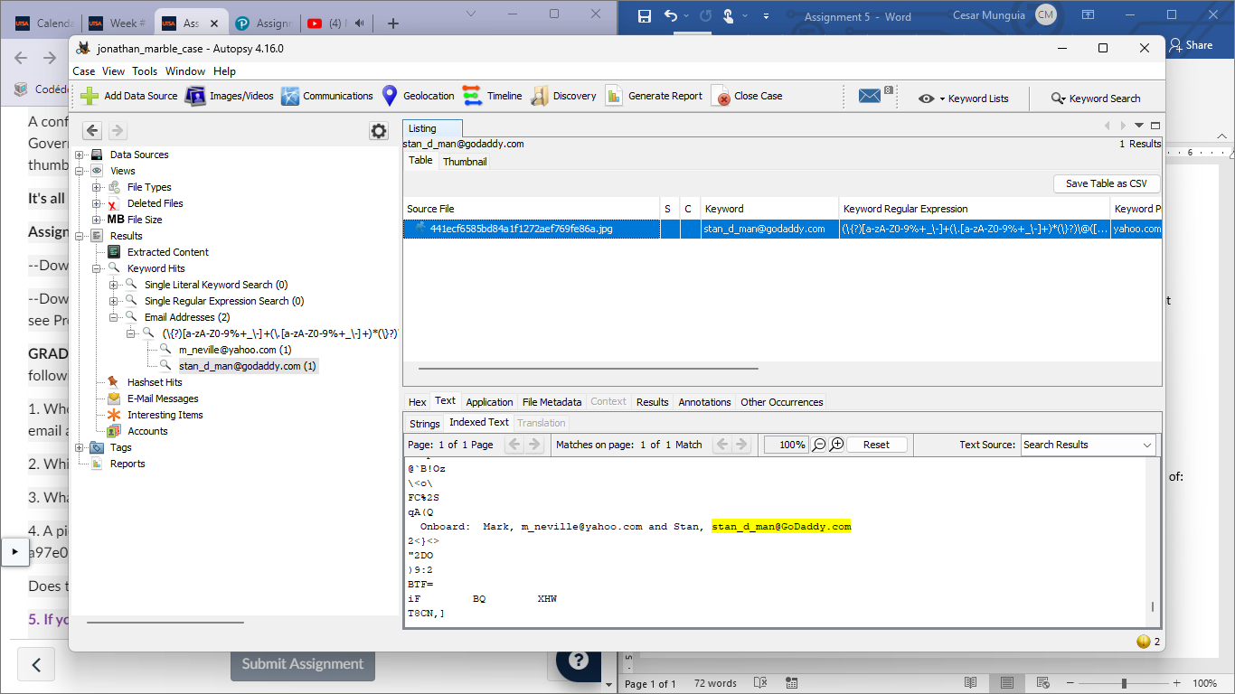

1. Which US Governor is the target?

I created a new list containing all the possible names that this suspect might be going after. I clicked Keywork Lists -> Manage List -> New List to create a new list with the names provided by our professor. Finally, I checked such list to execute the search. The suspect is going after Michelle Grisham.

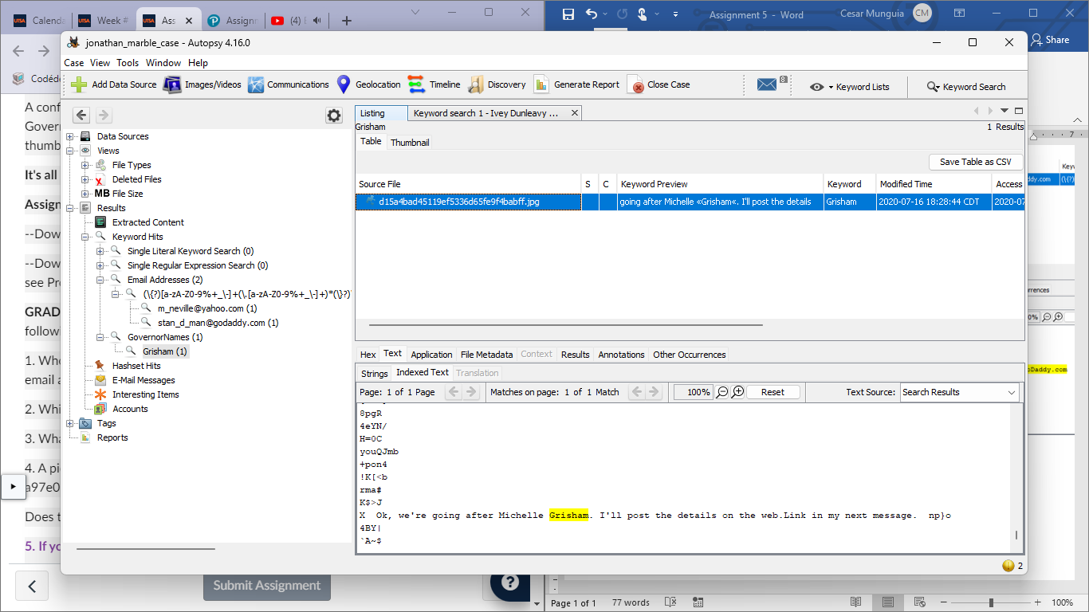

1. What are Marble’s plans?

Well, in the last message I found out that more information was going to be available in the web. So, using the Keywork Lists I checked the URLs box to look for any in the thumbdrive. I found that the URL is https://tinyurl.com/y82t9max which took me to a webpage containing a QR code. The next thing I did was to scan it with my phone’s camera and this message popped up in Safari: “The target’s outdoor TV interview”. So, it seems that the suspects are trying to intervene in a TV interview to kidnap the governor.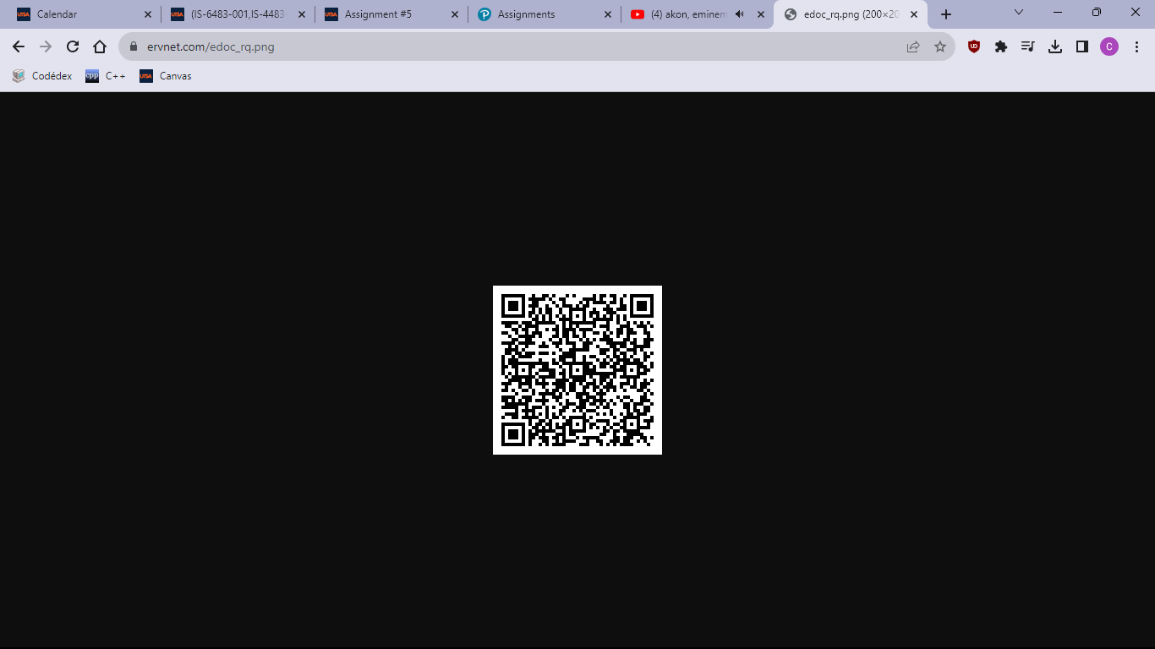

1. A picture of a weapon was uploaded to an extremist website with an MD5 hash of: a97e06676004cddbc6ddd00ecac5e5e3

Does this picture appear on Marble’s thumbdrive?

Yes. I looked up the hash value by going to Tools -> File Search by Attribute and then copied the hash value and pasted in the MD5 box to search for the picture.

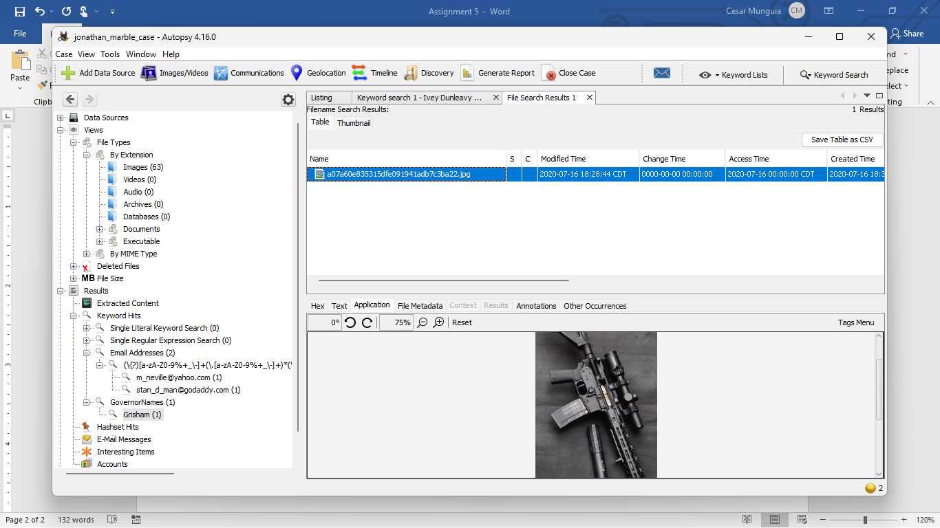

1. Cite 2 or more popular fuzzy hashing algorithms used today for similarity matching. Pick one and describe (in a paragraph) how the algorithm works.

I found these hashing algorithms used today for similarity matching: SimHash, MinHash, and Locality-Sensitive Hashing (LSH).

MinHash is a technique used to check the similarity between two sets of data. Whenever the hashes of both sets are made, they calculate their difference of both values and if it’s considerable low then it would mean that it’s related to other set of data. The lower the difference the more similarity, and oppositely, the greater the difference the less likely to be similar.